Holger Alexander Klein

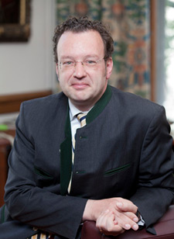

University of Columbia
Lisa and Bernard Selz Professor of Medieval Art History
Director, The Sakıp Sabancı Center for Turkish Studies
Columbia University

Professor Holger Alexander Klein obtained his PhD in 2000 from Rheinische Friedrich-Wilhelms-Universität. Holger A. Klein was educated in Art History, Early Christian Archaeology, and German Literature at the universities of Freiburg im Breisgau, Munich, London, and Bonn. His research focuses on Late Antique, Early Medieval, and Byzantine art and architecture, more specifically, on the cult of relics, reliquaries, and issues of cultural and artistic exchange.

Professor Klein joined Columbia University as an Assistant Professor in 2000, was promoted to tenured Associate Professor in 2006, and to Professor in 2011. He served as Director of Art Humanities in 2003 and from 2007–09, Director of Graduate Studies from 2010–12, and as Department Chair from 2012–15. During the 2015–16 academic year, Prof. Klein was Alliance Visiting Professor at the Université Paris I Panthéon-Sorbonne and taught Columbia undergraduates at Reid Hall. He currently serves as Interim Director of the Sakıp Sabancı Center for Turkish Studies.

